**Indicator variables**

Indicator variable is a feature engineering in this we convert feature into indicator variable.

Ex : we take height as a feature, this is a real valued feature

Now we convert this feature into Indicator variable, Indicator variable is binary Indicator variable.

As shown below if h> 150 then we assign 1 and if h <= 150 we assign 0

Here 150 is threshold value we can do this from domain knowledge.

Applying indicator variable is problem specific and we can easily convert feature into indicator variable using if else conditions.

We call it indicator variable because it indicates like if height is greater than 1 then assign 1 (or male because it is seldom that men height are less than 150)

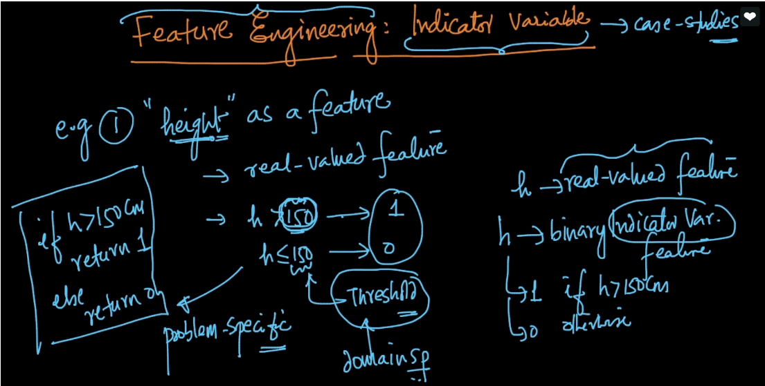

Ex2 : here we take categorical feature : country

We convert it into variable like if our problem required only country india or usa then we can write conditions as shown below.

We can apply here any logical conditions instead of or

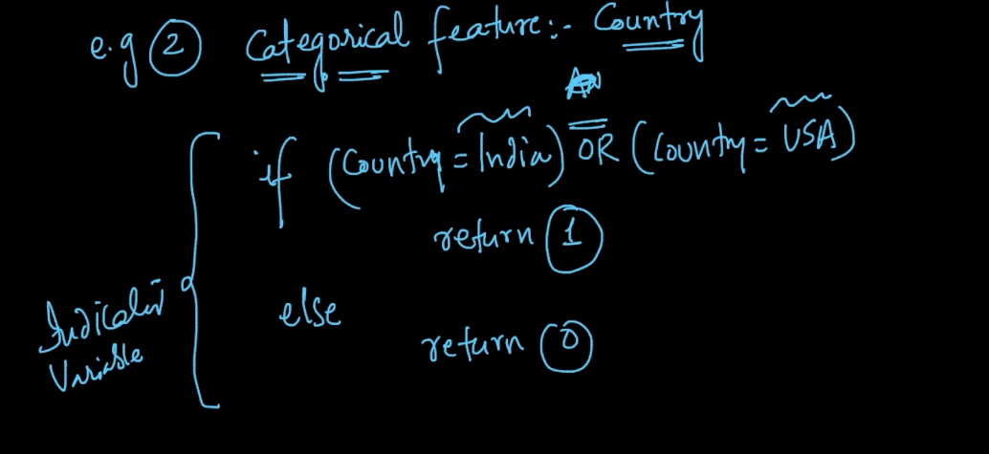

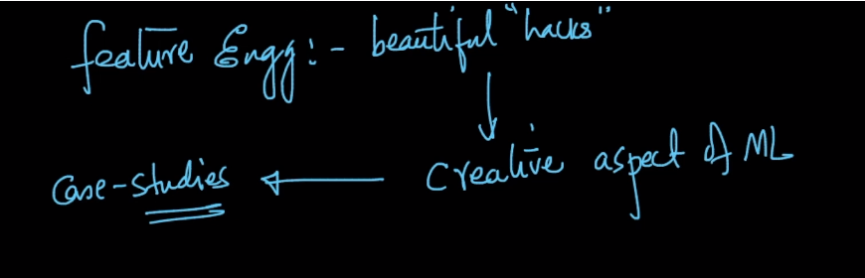

Comments :

